BANDA is a world music band from Slovakia. Since having been founded in 2003 it has been striving to follow its own road of perception of the genre. Slovak traditional music serves as our basic musical source. Nevertheless, with pleasure we mix it with foreign and extragenre material. We emphasize thorough knowledge of the folk musical tradition. The melody and the text of the song are not the only topic of interest for us, we are interested in the local
dialect, way of polyphonic singing, ornamentation, harmonization and rhytmization of the folk musicians as well. In its production, Banda uses acoustic instruments and their sample, rich vocals respecting tradition and local specialty, albeit in a new, original nature.
As samples of its most important performances let us mention Festival Pohoda Trenčín, Boatyard Piešťany, NAY Dance House, Folklore Festival Východná, concert series in Trondheim, Norway. As a particular success the band considers its participation at the world music festival in Rudolfstadt, Germany, the Folk Vacations in Námešť nad Oslavou, Czechia, and the Mikolajski Festival in Lublin, Poland, Tilburg (Netherland) The concerts in the Italian cities of Brendola, Viggiano and and Magliano, in Lvov, Ukraine, Plauen, Germany, Vienna and Krakow were successful as well.
Being said by words of Gerald Seligman, former Director of WOMEX "Banda are a group of excellent musicians who've figured out how to add contemporary elements to age-old tradition without losing the excitement of the former and the integrity of the latter."

Banda members:
Samo Smetana (violin, mandolin, bouzouki, tambourine, vocals)
Alžbeta Lukáčová (dulcimer, accordion, percussions, vocals)
Ivan Hanula (viola, mandolin, bouzouki, vocals)
Peter Obuch (bass, vocals)
Igor Ajdži Sabo (drums, percussion, vocals)
Eva Brunovská (vocal, keyboard)

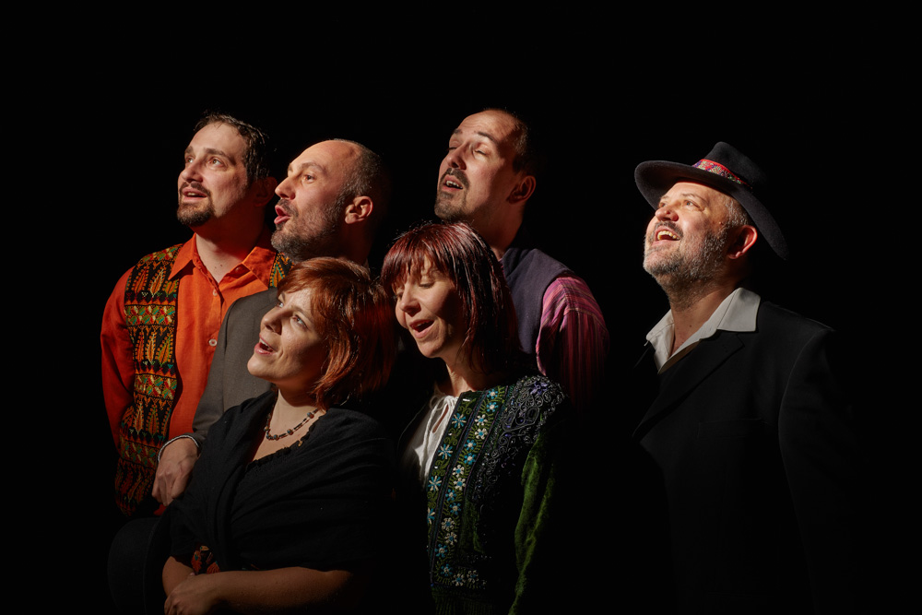
Cooperation
Occasionally, we collaborate with the female singers group Trnki from Banská Bystrica and with the bag-piper Juraj Dufek. Since Banda appears to be created for dance, it frequently works together with dance groups Partia and CreDance. Banda hosted the singer Zuzana Homolová as a frequent guest.

CD

Band jedna (Pavian Records, 2011)
– 8th place, World Music Chards Europe (10/2011)
– Nomination, World Music/Folk category of the Radio_Head Awards (2011) Musical Folklore Prize of the Svetozár Stračina Grand Prix for the song Janči, Janči (CD Fazuľa)

Hra Banda (Pavian Records, 2014)
– 4th place, Global Village Top 40 Albums For February 2015
– 14th place, World Music Chards Europe (1/2015)
– Album of the Week, FM Radio Slovakia (6/2014)
– Album of the Week, Vltava Radio Czechia (9/2014)
– 1st place for two weeks, 2nd place for one week for the song Nadeja at the Czech-Slovak hitparade of the Osmička radio_FM Slovakia (6/2015)
– Song Vývoda among the twenty most played songs of the 30th week of Radio Proglas, Czechia (6/2014)
– 1th place for the song Nadeja, Top 40 Tracks of World Music Charts by Ethnocloud (7,8,9,10/2015)
– 4th place for the song Javor, Top 40 Tracks of World Music Charts by Ethnocloud (8,9,10/2015)
– 1th place for the song Zozuľa, Top 40 Tracks of World Music Charts by Ethnocloud (1/2017)

Film
Dance between splinters (Marek Ťapák director, 2012) review
The clip for the song Šmerc has its origin in this film.
„1980“ (Peter Begányi director, 2017) historical detective series –the soudtrack (with the singer and leader of Korben Dallas band as a guest)

Media
– live concerts for Radio Slovakia (RTVS), included into the international offer of EBU (2004, 2006, 2008, 2013)
– clips from the records of Slovak TV (RTVS), e. g. Gesharim Bridges, Kapura folklore hitparade
– Hudba Mesta clip at tv.sme.sk

Organization of concerts
If all the Bands of the World is a double concert series organized regularly by Banda twice a year in DK (House of Culture) Zrkadlový háj in Bratislava-Petržalka. The concert consists of two parts. While Banda performs in the first part, in the second part a band or a musician of the world&ethno part is introduced. We particularly like songs we can play together. Making music in such a common way often results in a musical delicacy.

Press responses, reviews
názory.týždeň
…Banda (nielen slovenskému) folklóru veľmi dobre rozumie a práve preto na ňom dokáže s veľkým citom stavať svoju vlastnú hudbu… (more…)
17. July 2015

world-music.cz
O slovenské scéně world music toho moc nevíme. Tamní skupiny v Čechách koncertují zřídka a média je také nijak zvlášť neregistrují. K naší škodě: především bratislavská Banda si naši zvýšenou pozornost zaslouží. Novým albem hraBanda totiž znovu a velmi nadčasově mění povědomí o slovenské tradiční lidové hudbě uzavřené údajně do převážně folkloristických forem. (more…)
11. February 2015

Musicframes.nl
The group Banda is based in Slovakia, Bratislava at the river Danube near the Austrian and Hungarian border. Also on their second album ‘hraBanda’ the group plays traditional folk, fresh arranged. In an acoustic environment we hear the Slovak history: innovative and detailed. (more…)
3. October 2014

Hudba_FM
Druhý album skupiny Banda je o kúsok zrelší ako ich debut, ktorý to dotiahol až do prvej desiatky rebríčka WMCE. Tentoraz sú v ponuke ešte sladšie čerešne. (more…)
4. September 2014

Gatki z Chartki 6/2014
Zespól Banda powstal w 2003 roku i od poczatku prezentuje slowacka muzyke etniczna w nowoczesnych opracovaniach. (more…)
30. June 2014

